[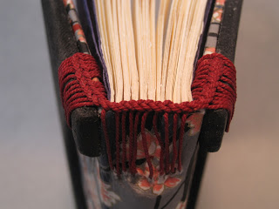](http://4.bp.blogspot.com/-Jsm5FcResTw/UC5dAcD9vDI/AAAAAAAABRE/KK73LZFS2pk/s1600/2.JPG)